Einstein Riddle III 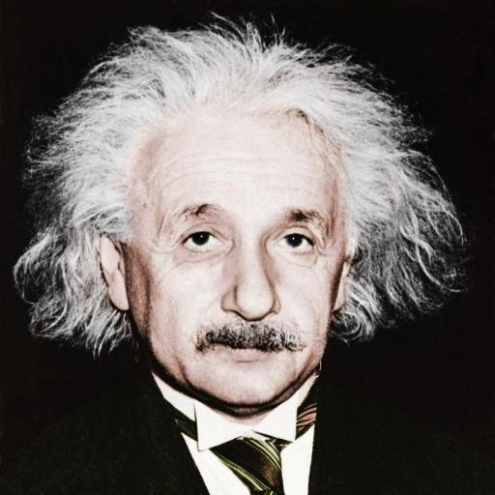

Five friends have their gardens next to one another, where they grow three kinds of crops: fruits (apple, pear, nut, cherry), vegetables (carrot, parsley, gourd, onion) and flowers (aster, rose, tulip, lily).
- They grow 12 different varieties.
- Everybody grows exactly 4 different varieties
- Each variety is at least in one garden.
- Only one variety is in 4 gardens.
- Only in one garden are all 3 kinds of crops.
- Only in one garden are all 4 varieties of one kind of crops.
- Pears are only in the two border gardens.
- Paul's garden is in the middle with no lily.
- Aster grower doesn't grow vegetables.
- Rose grower doesn't grow parsley.
- Nuts grower has also gourd and parsley.
- In the first garden are apples and cherries.
- Only in two gardens are cherries.
- Sam has onions and cherries.
- Luke grows exactly two kinds of fruit.
- Tulips are only in two gardens.
- Apples are in a single garden.
- Only in one garden next to the Zick's is parsley.
- Sam's garden is not on the border.
- Hank grows neither vegetables nor asters.
- Paul has exactly three kinds of vegetable.

Who has which garden and what is grown where?

Person | 1 | 2 | 3 | 4 | 5
Crop 1
Crop 2
Crop 3
Crop 4

