Forensic Science
History of Fingerprinting Notes
1) ____________________________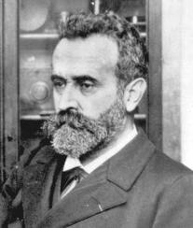
- In _________he created the first systematic system of ________________________ classification & identification.
- Detailed description of subject, full-length & profile photographs & a system of precise body measurements (called _______________________________).

2) _____________________________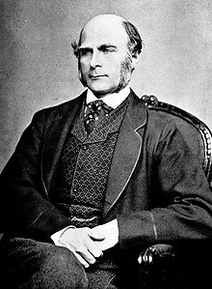
- British ____________________________________and a cousin of Charles Darwin, began his observations of _____________________________as a means of identification in the 1880's.
- In ___________, he published his book "Fingerprints“, establishing the _____________________________ and permanence of fingerprints. The book included the ____________________________________________classification system for fingerprints.
- Galton's primary interest in fingerprints was as an aid in determining ___________________ and racial background.
- He soon discovered that fingerprints offered ________firm clues to an individual's intelligence or ____________________________.
- He demonstrated that fingerprints _____________________________ over the course of an individual's lifetime, and that _______________________ fingerprints are exactly the same.
- According to his calculations, the odds of two individual fingerprints being the same
were 1 in ___________________________________.

3) ________________________ Case and Bertillon Measurements
- _____________: For many years, scientists did not use fingerprinting as a serious tool for identifying criminals. Instead, they used a system which recorded the dimensions of certain skeletal body parts (known as the _______________________________). But in 1903, Leavenworth Federal Penitentiary received a prisoner by the name of _____________________.
- Shockingly, Will had almost the same Bertillon measurements (as well as appearance) as another prisoner currently serving a life sentence for murder. But even though the two unrelated criminals looked _____________________________, and had similar names (the other inmate’s name was William West), their ___________________________were, of course, different. Thanks to this remarkable case, fingerprinting became the ____________________ for personal identification.
You be the judge….Can you see the difference?
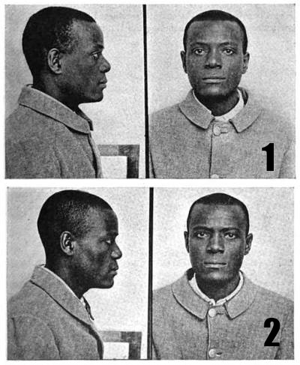

4) Fingerprint Information—What Have We Learned?
- The patterns of ____________________ on our finger pads are unique: no two individuals—even ___________________________________—have fingerprints that are exactly alike.
  - We leave_____________________________—or prints—of these patterns on everything we touch with any pressure.
  - The prints can be __________________________, as when our fingers are dirty or oily, or they can be _________________________, as when they are made only by the sweat that is always present on our finger ridges.
  - Injuries such as burns or scrapes will ______change the ridge structure: when new skin grows in, the same _______________________will come back.
- _________________________________________ is the practice of using fingerprints to identify someone. Fingerprints can be classified by pattern _________________, by the __________________of those patterns, and by the ______________________of the patterns on the finger.

