Forensics Fibers & Hair

Name:__________________
Period:_________________

- Write down the % of fabric types found in an item of your clothing:

- What attributes of a fabric type make them suitable for specific clothing function?

  - Warm:

  - Cool:

  - Smooth, non wrinkled:

  - Wicking (drying quickly)

  - Flexible/Stretchy

  - Long Wearing

  - Stiff/Strong

  - Dyeing/coloring

- What fabrics are derived from plants?

- What fabrics are derived from animals?

- What fabrics are man made in laboratories and factories?

Microscopic picture of fabrics

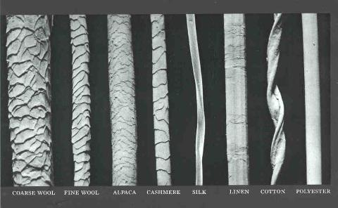

Shark Skin
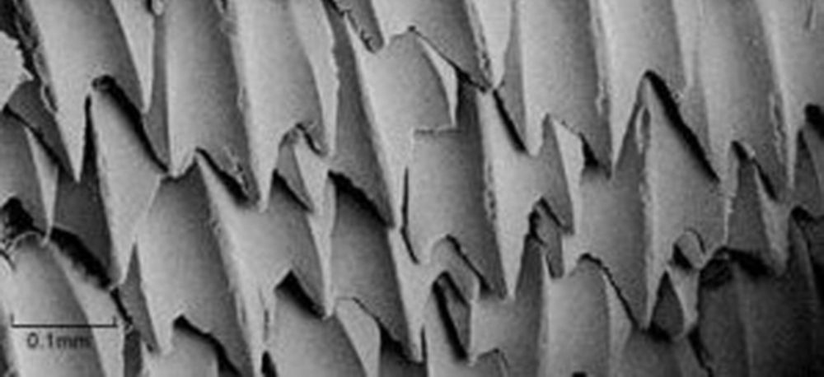

Spider Silk Spigots

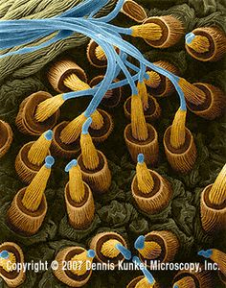

Now developing artificial spider silk – stronger than steel on a mass basis
http://web-jpn.org/kidsweb/hitech/spider/index.html

COTTON Chemistry

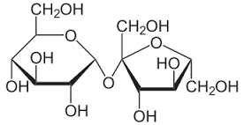

Polyester Chemistry
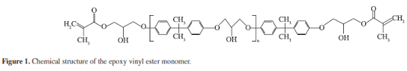

NYLON Chemistry
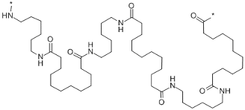

Acrylic Chemistry
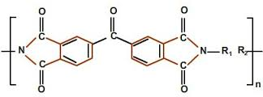

Polypropylene Chemistry

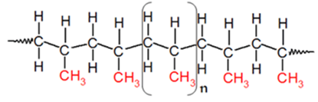

WOOL Chemistry

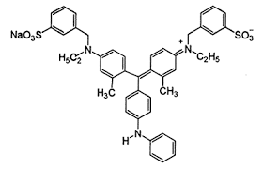

SILK weave
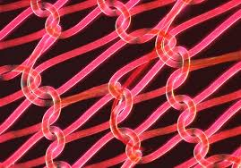

HUMAN Hair

Imbricate Cuticle
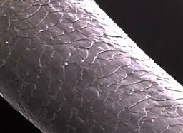

< .3 Medullary Ratio
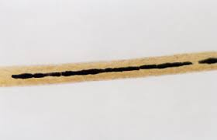
DOG Hair Cuticle : Imbricate
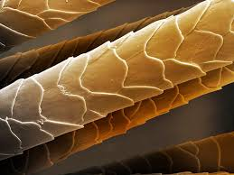

Dog Medullary Index ~ 0.5
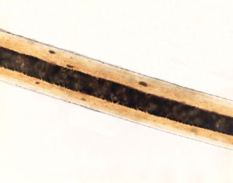

RAT Hair
Cuticle Type : Coronal

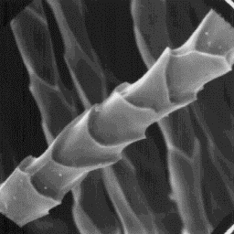

CAT HAIR:
Cuticle Type: Spinous
