NOTES on SEROLOGY & Blood Splatter Name:_______________________
Period:________

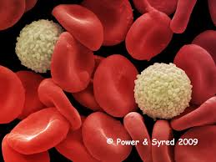

Serology is the examination and analysis of body fluids including:

  - Urine
  - Semen
  - Blood
  - Saliva

Erythrocytes are ____________ blood cells with a cell count of _______________________

Leukocytes are ________________ blood cells with a cell count of _______________________

Thrombocytes or ______________________ are responsible for blood _______________ & have a cell count of ____________________

Human Blood Groups :

Rh factor: Positive (present) or Negative (not present)
In terms of (American) Racial groups Rh positive factor is present in the following %
  - 85 % Caucasians
  - 94 % African Americans
  - 99 % Asians

Antigens are ____________________________________________

Antibodies are _________________________________________

Agglutination is ___________________________

How DO you determine if a stain is blood?

Tests to determine if a stain is blood:

  - Kastle Meyer Color Test

  - Hematest Tablet

  - Luminol Test

How do you decide if blood stain is HUMAN?

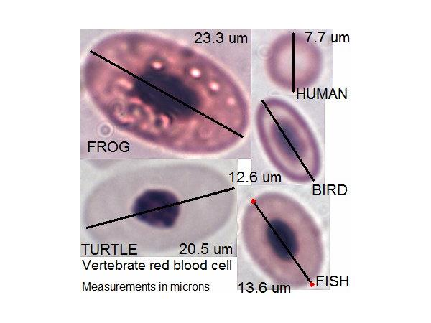

- Microscopic Observation – Animals have larger nucleic red blood cells, also more elliptical

- Precipitin Test: blood is injected into live rabbit (or other animal) where antibodies are formed in the rabbit’s blood. Then, a blood sample is taken from the rabbit & exposed to the unknown blood sample. The injected rabbit blood will react with human proteins if human blood is present in the unknown sample, forming a blood clot.

Blood Group/Blood Typing INnformation

Type | Antigen | Antibody | Can give blood to | Can get blood from
A | A | B | A, AB | O, A
B | B | A | B, AB | O,B
AB | A B | Neither A nor B | A B | A, B, O, AB
O | Neither A nor B | A B | A, B, O, AB | O

Is Blood Evidence Class or Individual Evidence?

Blood Splatter Evidence is considered ____________________________evidence

Blood Stain patterns provide evidence of “

  - Direction of blood travel

  - Height of origin of force producing splatter

  - Position of victim

  - Whether perpetrator is right or left handed

What are the blood splatter pieces of evidence that are used to convict Darlie Routier of the murder of her two young sons? Describe in detail, based on Video

- On her clothing

- On vacuum cleaner

- On floor

- Knife impression blood

- Garage Window Screen

- Blood Splatter remains illuminated with Luminol

- What is evidence for against someone outside the house commiting this crime?

Direction of Blood Splatter relative to Vertical:

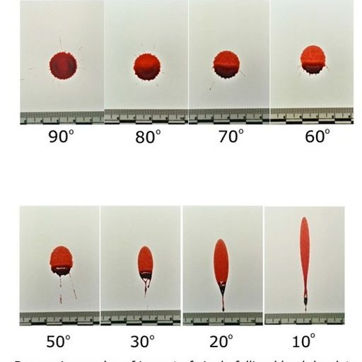

Calculation of impact angle
Impact Angle = arc sin (drop width, w/drop length, l)

Use centimeter stick to confirm the angles shown in the images above and report in the table below:

Reported Angle | Width, mm | Length, mm | w/l | Angle  calc
90
80
70
60
50
40
30
20
10

Direction of Blood Travel:

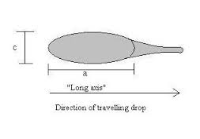

Area of Convergence: the spot where the blow occurred. (blood drops emerge from this point)
How are each of these relevant to the Darlie Routier Case? The Sam Sheppard Case?

What Blood Splatter can reveal:

Length of time since crime committed

Whether death was immediate or delayed

Evidence contradicted by witness statements

Order in which events occurred

Which wounds were inflicted when

Handed-ness of the assailant

