Prints Chapter 4
- Based on your knowledge of shoe prints, sequence the prints in order of oldest to newest. _________ __________ __________
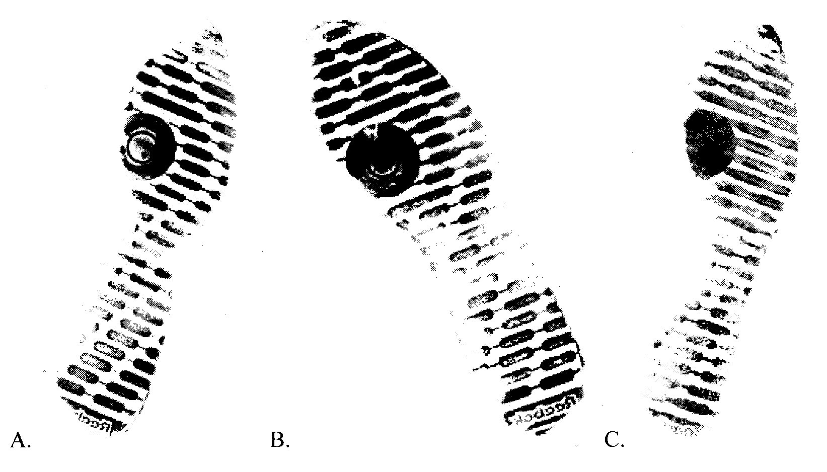

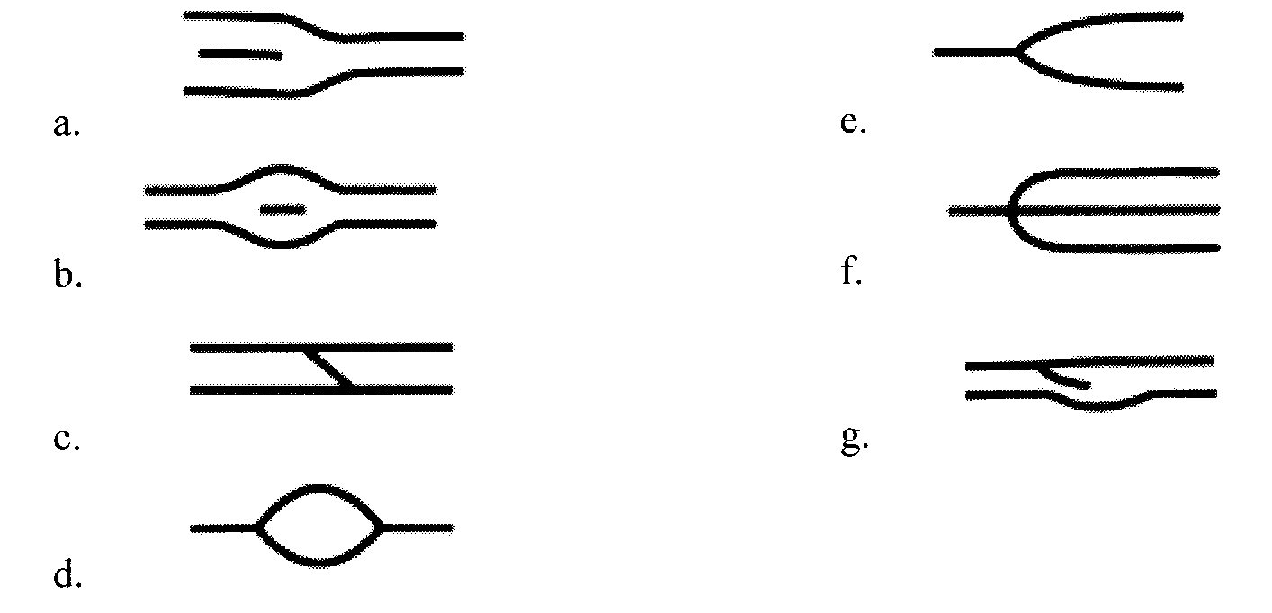
Match the following with their name.

- Bifurcation _________
- Bridge _________
- Eye or enclosure _________
- Island or short ridge _________
- Ridge ending _________
- Spur _________
- Trifurcation _________
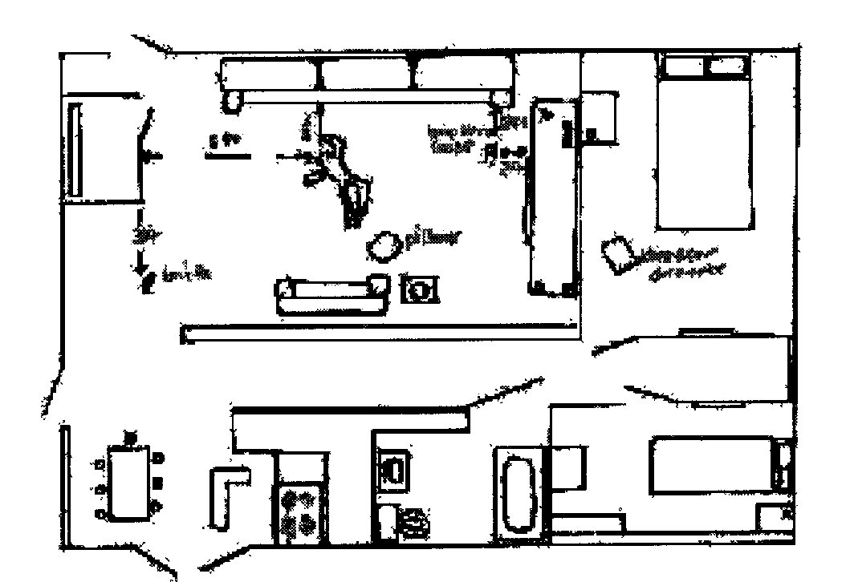
- What five additional pieces of information would need to be added to this crime scene sketch before it could be submitted?

- __________________________________________________
- __________________________________________________
- __________________________________________________
- __________________________________________________
- __________________________________________________
- Record the general fingerprint for the MO card below. Ex. Loop, whorl,…
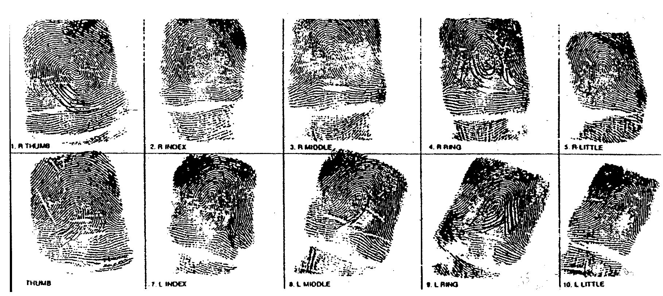
_________________________ ____________________________

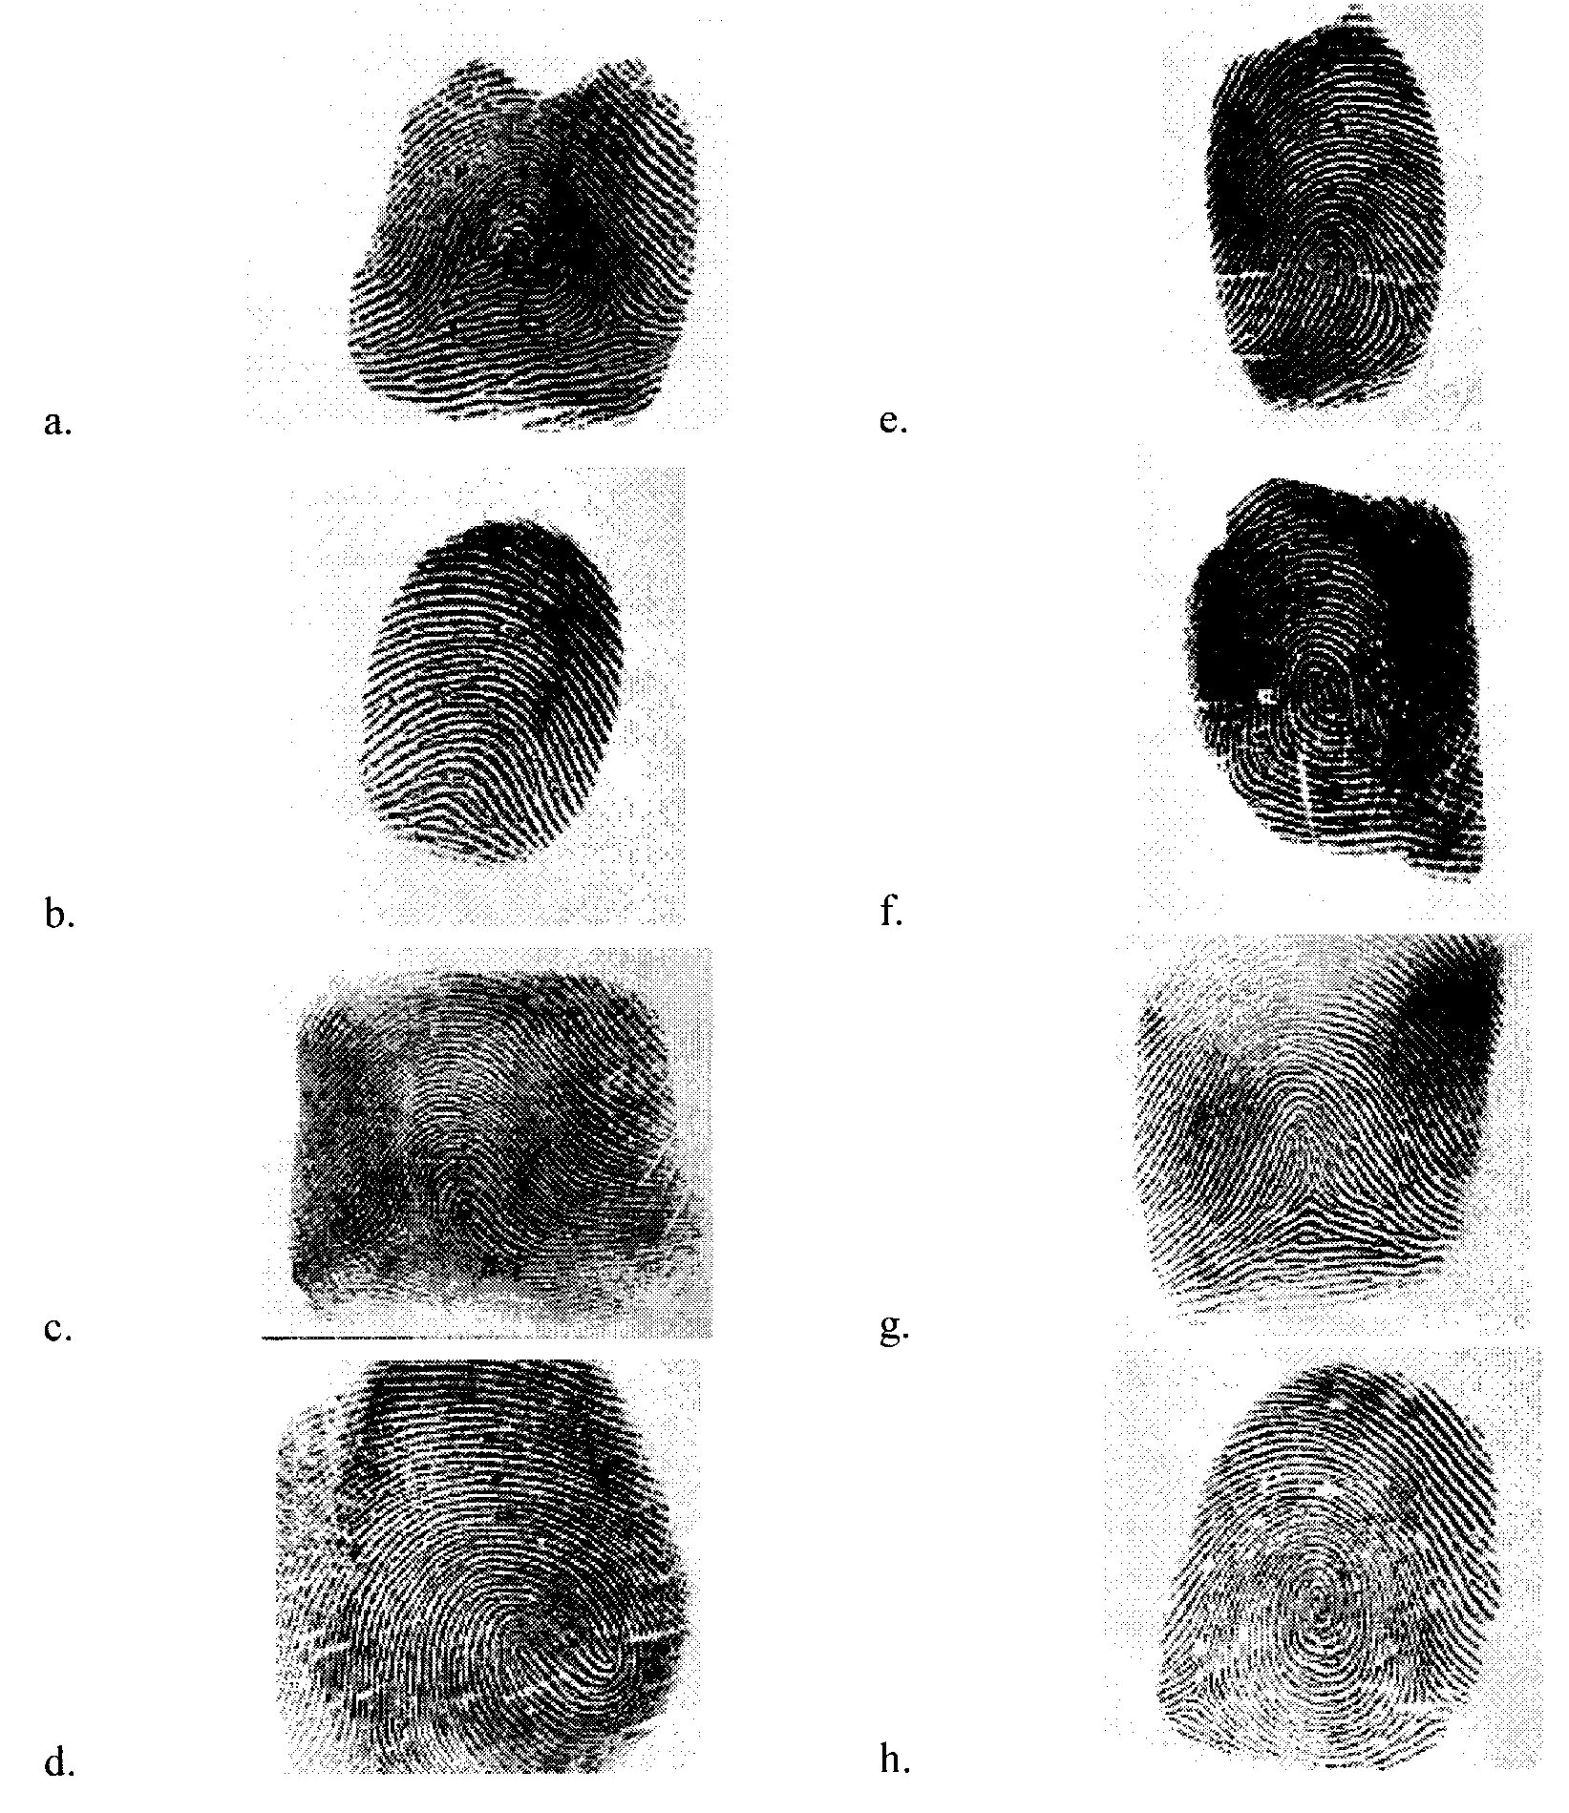
Match the following patterns with their name. Assume that all prints come from the right hand.

- Accidental _________ Central pocket _________
- Double loop _________ Plain arch _________
- Plain whorl _________ Radial loop _________
- Ulnar loop _________ Tented arch _________

- Draw a line from and label the following parts and minutiae. Be very specific as to where you end your line.
- Core
- Delta
- Ridge ending
- Bifurcation
- Dot
- Short ridge


